Activity 2.2.2 Mechanical Gears
NAME: NAME: NAME: Class:____
Name of Gear | Teacher sign off: | Questions  & Video watched | Student Sign off:
Simple Gear Train  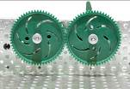 |  | 1----11
Simple Gear Train “with Idler”  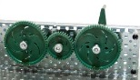 |  | 1---9
Bevel Gear  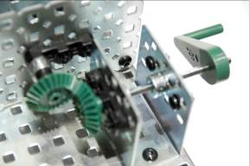 |  | 1---7
Worm and Wheel  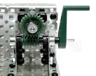 |  | 1---8
Chain Drive  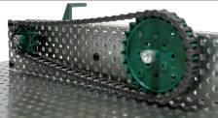 |  | 1---9
Belt Drive  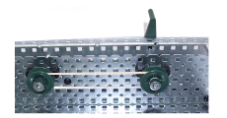 |  | 1---10
Name of Gear |  | Total Points:  /108

