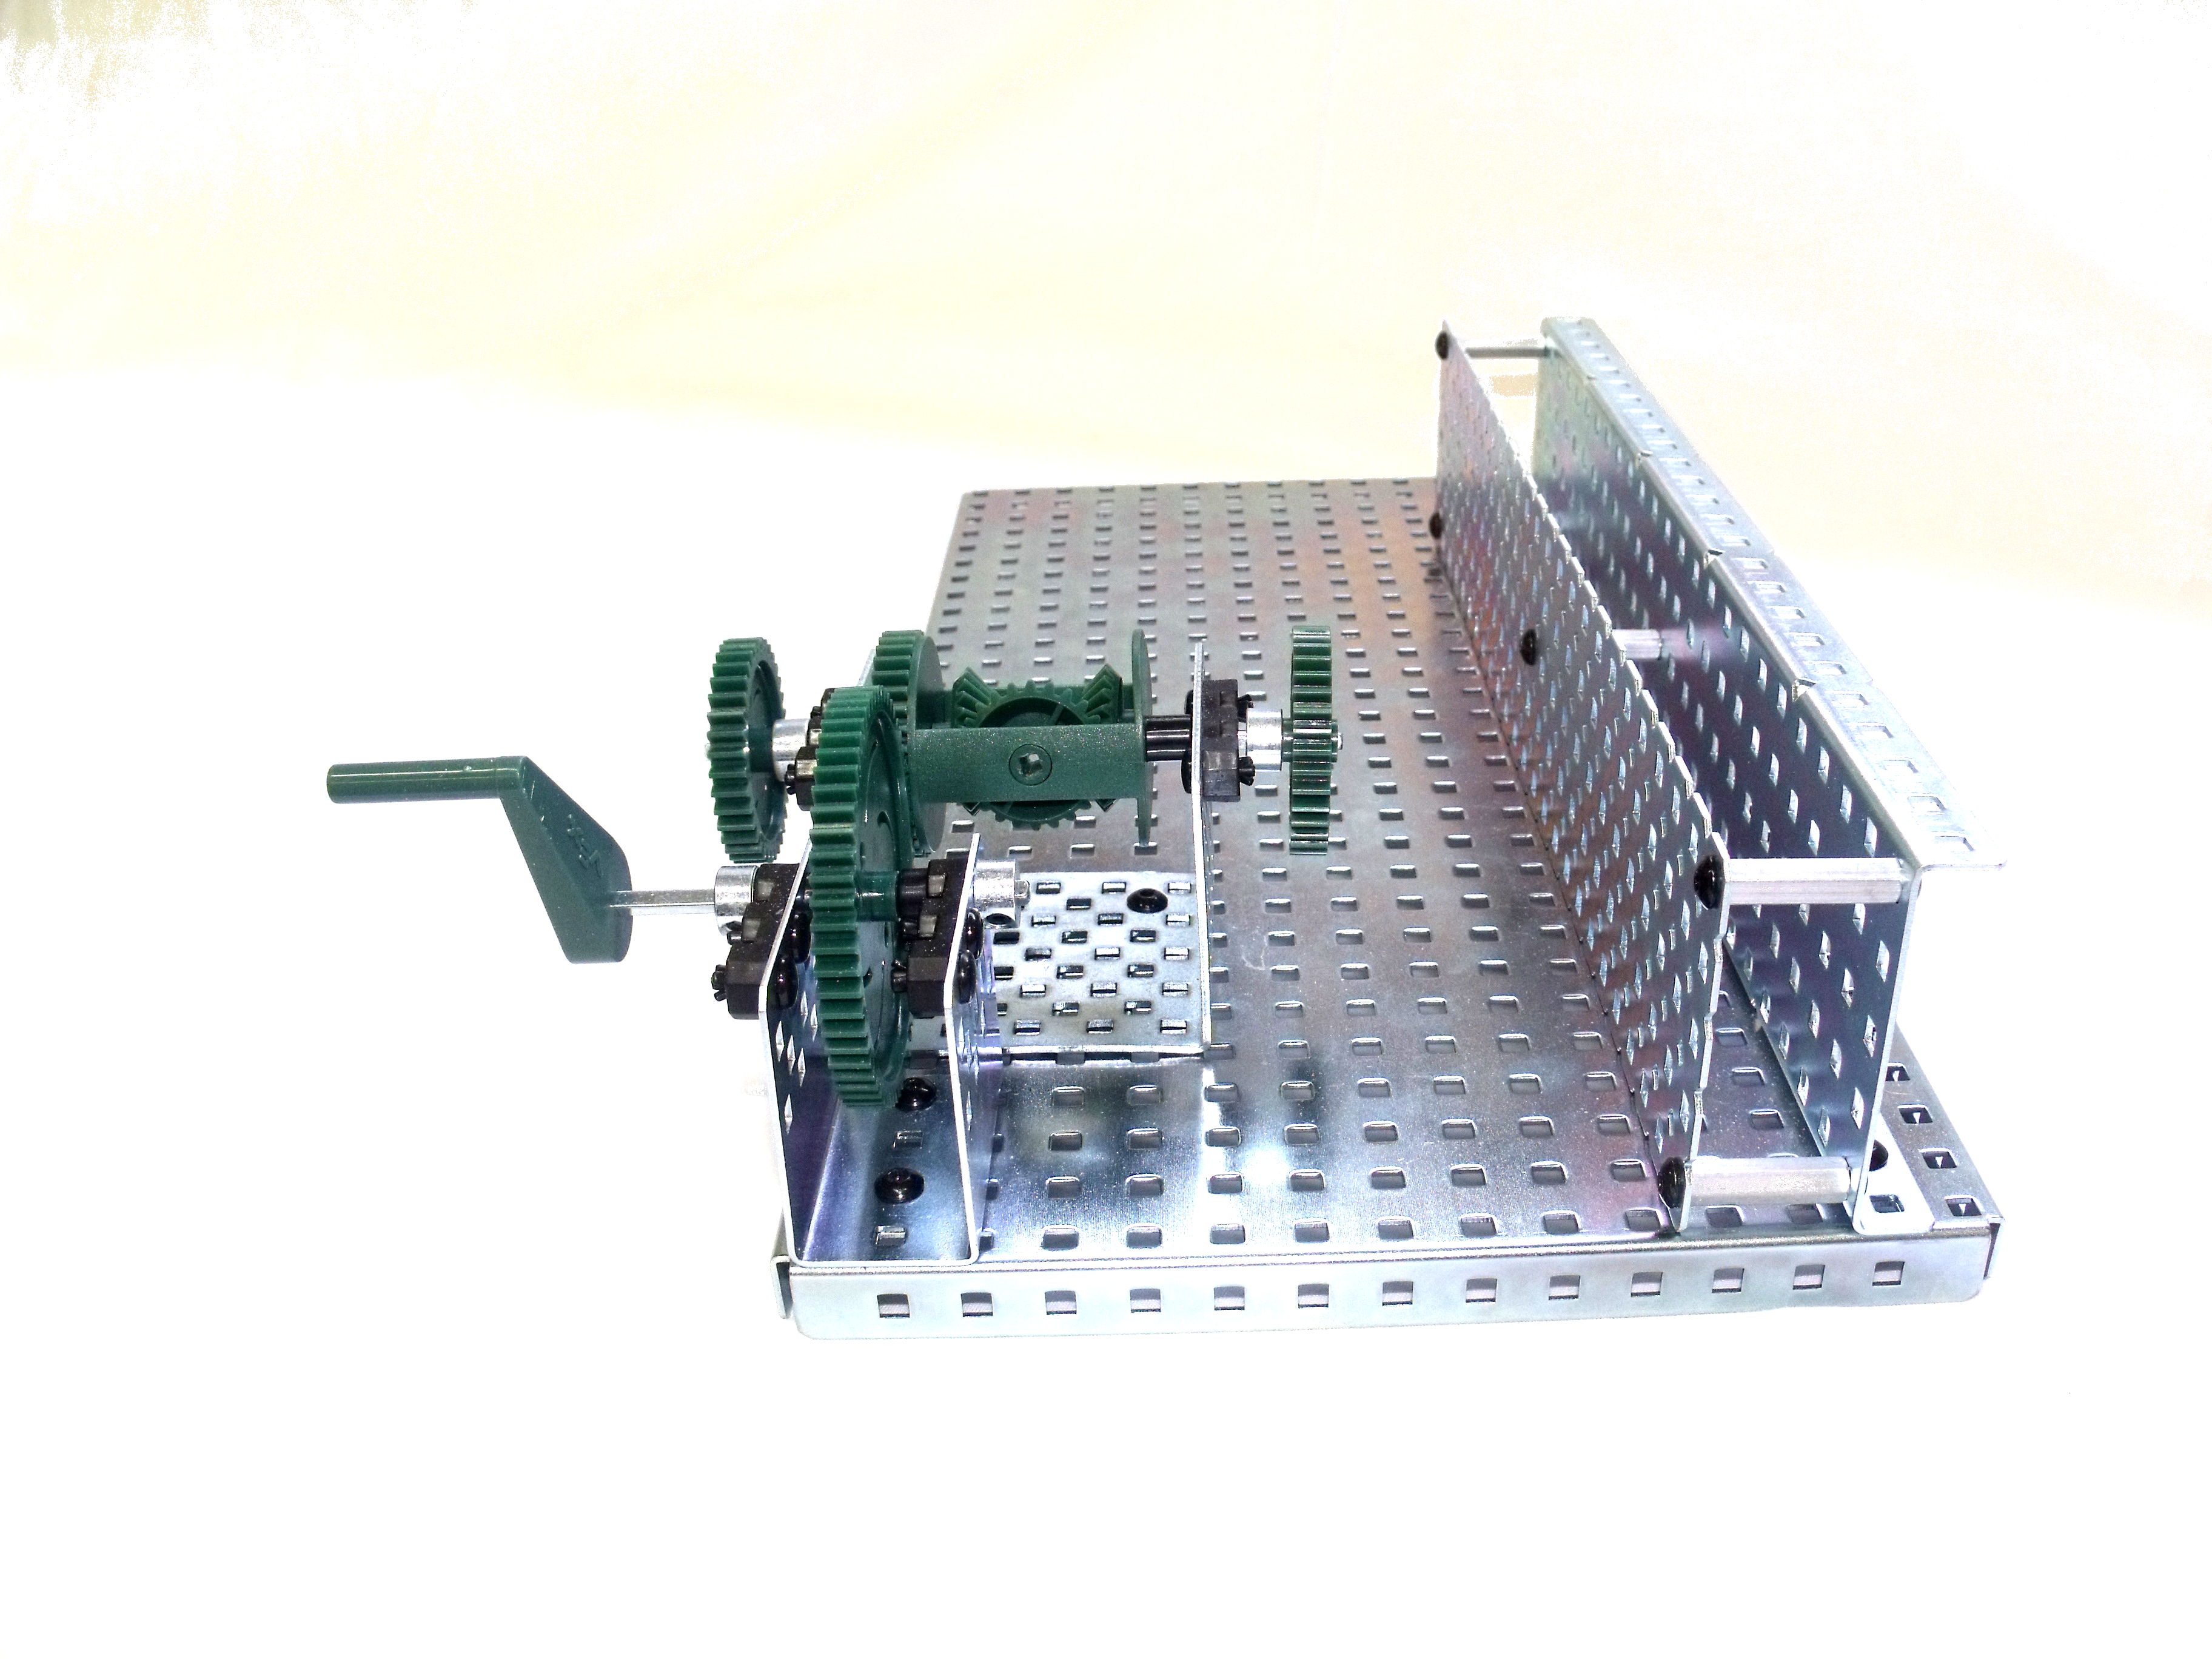

Simple Gear Train  - What is the relationship of the input shaft compared to the output shaft?  - Label the drive and driven gears.  - In gear train A, is the speed increased, decreased, or constant?  - In gear train B, is the speed increased, decreased, or constant?  - In gear train A, is the torque increased, decreased, or constant?  - In gear train B, is the torque increased, decreased, or constant?  - What is the gear ratio of gear train A?  - What is the gear ratio of gear train B? | A.  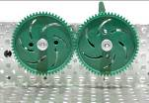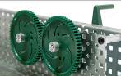  B.  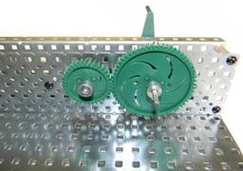
- Is the flow of power reversible? (Can you make the input shaft turn by turning the output shaft?)
- Do the gears move in the same or in the opposite direction?
- Example: Videos, Pictures, general information
http://www.youtube.com/watch?v=1JSTJX6M0Kw&safe=active
www.howstuffworks.com and use keyword: Gear train.

Simple Gear Train with Idler  - What is the relationship of the input shaft compared to the output shaft?  - Label the drive, driven, and idler gear.  - Is the speed increased, decreased, or constant?  - Is the torque increased, decreased, or constant? | 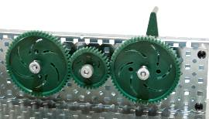
- What is the gear ratio?
- Is the flow of power reversible? (Can you make the input shaft turn by turning the output shaft?)
- What is the direction of travel between the input and output gears?
- Predict what the direction of travel would be between the input and output gears if the idler gear was eliminated from the mechanism.
- Example: Videos, Pictures, general information
List an example http://www.youtube.com/watch?v=67uDjMz6EpA&safe=active
www.howstuffworks.com and use keyword idler gear.

Bevel Gear Assembly  - What is the angle of the input shaft compared to the output shaft?  - Is the speed increased, decreased, or constant?  - Is the torque increased, decreased, or constant?  - If the input gear was larger than the output gear, how would that affect the speed and torque? | 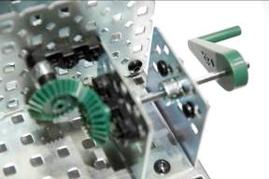
- What is the gear ratio?
- Is the flow of power reversible? (Can you make the input shaft turn by turning the output shaft?)
- Example: Videos, Pictures, general information
http://www.youtube.com/watch?v=ymHzbN1oK1w&safe=active
www.howstuffworks.com and use keyword bevel gear.
Chain Drive  - Label the drive and driven gears.  - What is the angle of the input shaft compared to the output shaft?  - In gear train A, is the speed increased, decreased, or constant?  - In gear train A, is the torque increased, decreased, or constant?  - In gear train A, what is the input to output ratio?  - What happens to speed, torque, and gear ratio if the smaller gear becomes the drive gear (shown in picture B)?  - Does the input shaft turn in the same or opposite direction of the output shaft? | A.  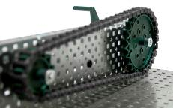  B.  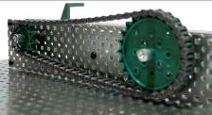
- List an example of where this mechanism might be used. For help, go to www.howstuffworks.com and use keyword chain drive.
- What is the advantage of using a chain drive over spur gears?
Belt Drive  - Label the drive and driven pulleys.  - What is the angle of the input shaft compared to the output shaft?  - Is the speed increased, decreased, or constant?  - Is the torque increased, decreased, or constant?  - What is the input to output ratio? (Measure the number of rotations on the driven and driving axles.)  - What happens to speed and torque if the drive pulley is larger?  - Does the input shaft turn in the same or in the opposite direction of the output shaft?  - What happens if the belt is crossed?  - List an example of where this mechanism might be used.  - Why would you use a belt drive instead of a chain drive? | 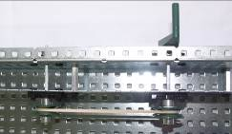  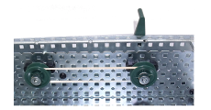  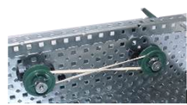

Worm and Wheel  - What is the angle of the input shaft compared to the output shaft?  - Is the speed increased, decreased, or constant?  - Is the torque increased, decreased, or constant?  - Label the worm and wheel gears.  - What is the gear ratio?  - Is the flow of power reversible? (Can you make the input shaft turn by turning the output shaft?) |  | 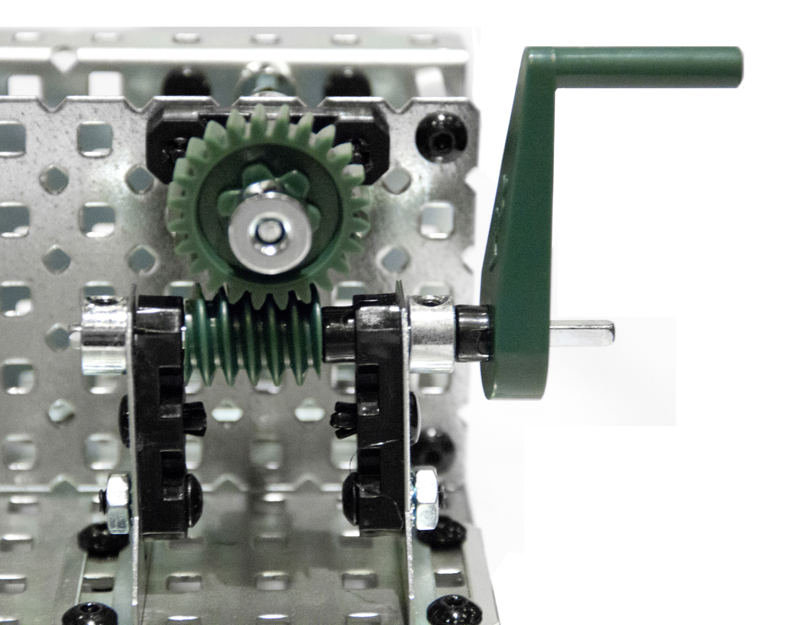
- Is the direction of travel reversible? (Does the mechanism still work if the input shaft is turned in the opposite direction?)
- List an example where this mechanism might be used. For help, go to www.howstuffworks.com and use keyword worm gear.

