NAME:_________ NAME:________CLASS:____ 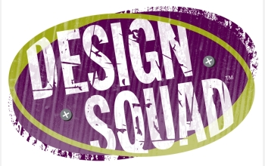 TEAM #1 _ Team #2
State the problem?

How did the team use Brainstorming to develop their ideas.
How did they conduct their research?
Did they conduct Research?
How did the team Develop Ideas for their inventions?
How did the team choose the Best Idea for their product?

Describe their Model or Prototype the team designed.
How did they Test and Evaluate their product?
Did they Improve the Design
Results which team were chosen as the winner?

