 | 

Project 2.3.4 Automation Through Programming

Introduction
Congratulations! You have just landed your dream job. All of those hours you spent building and programming robots and gadgets when you were younger are about to pay off. Not many people are paid to play all day. The only problem is the manager told you the projects are a little behind. Boy, is that an understatement! The good news is that you are allowed to put together a team of three people to help you get the work done, and you will have access to all of the materials in the lab. Successful engineers need to collaborate and cooperate with one another. Looking around, you realize it’s time to get started.

Equipment
- GTT notebook
- Pencil
- VEX parts, Cortex
- Computer with ROBOTC program installed
- Computer with Autodesk Inventor (optional)
- Problem sheets

Procedure
- Your teacher will help divide your class into groups of approximately three students.
- Read over the problems and discuss who will assume the primary responsibility for the engineering jobs. The duties are specified on each problem sheet. Everyone on the team will take part in all phases of the design process, but one person will be primarily responsible to see that the job gets done. Each team member is expected to complete and submit for evaluation a problem sheet for each task. The three engineering jobs should be changed for each task so that everyone has the opportunity to experience all three types of jobs.
- Mechanical Engineer
- Electrical Engineer
- Computer Engineer
- Begin working on the problems. Make sure to document your design process in your GTT notebook and complete the problem sheets provided by your teacher. Your teacher may require you to use the Autodesk program to sketch at least one of your problem solutions on the computer. Keep up with your progress on the problem check-off sheet.

Task #2 – Spinning Sign | 

Mission:
A marketing firm has determined that more customers will enter a shop if the sign is neat and eye-appealing. To increase business you decide to design and build a spinning sign with a catchy title for outside your shop. To conserve energy, you must install a stop switch for the sign when the business is closed. This stop system should be able to be engaged by a person on the ground away from the sign.

Bonus: Add a second switch to turn the sign back on.
Duties:
Mechanical Engineer: You must design a mechanism (not just a slower speed on the motor) that will rotate a sign at a slow speed. Sketch your solution on the lab sheet in the mechanical engineering section, label all sensors and motors.

Electrical Engineer: You should assist the mechanical engineer in the placement of the motor and switch(es). Once these components are placed, connect the motor and switch(es) to the microcontroller using wires. Complete the wiring diagram on the lab sheet.

Computer Engineer: While the other engineers are busy working, you must write a program that will control the sign. The program should cause the sign to rotate when the program is started and stop the rotation when the switch is pressed and the business is closed. Don’t forget that the purpose of the sign is for people to read it. If the sign rotates too quickly, it will be difficult for potential customers to read.Open the PLTW Template and Save As SpinningSign to your directory. Complete each section:
- Heading
- Task Description
- Pseudocode
- Motor and Sensors Setup
- Program
Print and attach to the lab sheet. Show your completed Spinning Sign to your instructor when you turn in your lab sheets.

Task #1 – Robot Drag Race | 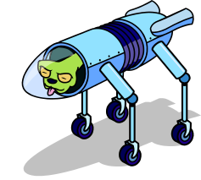  

Mission: Your team’s challenge is to create a robot which can cross a 20 ft distance in the least amount of time possible when a pushbutton switch is pressed to start it. You can race multiple robots built by other teams against each other or play against the clock and keep track of your time to see which team designs and builds the fastest robot.
Bonus: Program your robot dragster to stop as soon as it crosses the line at 20 ft.
Duties:
Mechanical Engineer: You must design a robot that will optimize drivetrain acceleration in a 20 ft distance using no more than two motors. If the robot is geared too fast, it will accelerate slowly which will cost it time. There is a balance between acceleration and top-speed which each team must find. Experiment with the different tires and gears available. Sketch your solution on the lab sheet in the mechanical engineering section, label all sensors and motors.

Electrical Engineer: You should assist the mechanical engineer in the placement of the motors and sensors. Once these components are placed, connect the motor(s) to the microcontroller using the attached wires. Complete the wiring diagram on the lab sheet.

Computer Engineer: While the other engineers are busy working, you must write a program that will propel the robot forward as quick as possible. Open the PLTW Template and Save As DragRace to your directory. Complete each section:
- Heading
- Task Description
- Pseudocode
- Motor and Sensors Setup
- Program
Print and attach to the lab sheet. Show your completed Drag Racing Robot to your instructor when you turn in your lab sheets.

Task #3 – Terry Traffic Tamer | 
Mission:
Your mission is to install a traffic light control system that will enable you to keep traffic moving smoothly. From your traffic control center, you see on a video monitor that an ambulance is coming. Install a pushbutton switch to reset the light program so that you can adjust the time for the red light to stay on while the pushbutton is pressed to get the emergency vehicle safely through the intersection.

Bonus: Use a timer to determine the light sequence location. When the pushbutton is released the light sequence should immediately turn to green and continue the sequence.
Duties:
Mechanical Engineer: You must build a model of a traffic light with green, yellow, and red lights. When Terry presses and holds an emergency switch, the signal will change from green to yellow to red. After the emergency vehicle has gone through the intersection, Terry should be able to release the switch to turn the signal from red to green. Sketch your solution on the lab sheet in the mechanical engineering section, label all sensors and motors.

Electrical Engineer: You must work with the mechanical engineer and computer engineer to wire the three lights and pushbutton. Complete the wiring diagram on the lab sheet.

Computer Engineer: While the other engineers are busy working, you will write a program to control the signal light. The program should be written so that the green light turns on when the program is started. The red and green lights should each be on for 5 seconds, the yellow light for 1 second. Make sure only one light is on at a time. When an emergency switch is pressed, the yellow to red light sequence should begin, and the red light should stay on while the button is pressed. When the same switch is released, the light should change from red to green. Open the PLTW Template and Save As TrafficLight to your directory. Complete each section:
- Heading
- Task Description
- Pseudocode
- Motor and Sensors Setup
- Program
Print and attach to the lab sheet. Show your completed Traffic Light project to your instructor when you turn in your lab sheets.

Task # 4– Toll Booth | 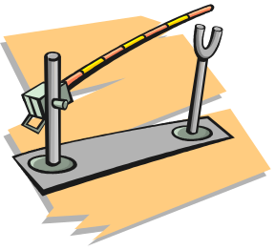
Mission:
The local airport needs to place a toll booth gate at the exit. One sensor will be needed to open, and one to close, the toll booth gate. A red light should be on when the gate is down or moving. When the vehicle goes through the intersection the gates will be up and the light off.

Bonus: Add a green light to indicate that the car can go through the gate.
Duties:
Mechanical Engineer:
Your job will be to construct a motorized gate with a potentiometer that will rotate 90º. Sketch your solution on the lab sheet in the mechanical engineering section, label all sensors and motors.

Electrical Engineer:
You will connect the sensors, light(s), motor and potentiometer to the microcontroller. Complete the wiring diagram on the lab sheet.
Computer Engineer:
When designing the program, you must keep in mind the following:
- The red light is on when the gate is moving down, when the gate is across the road and when the gate is moving up.
- The red light is off if the gate is in the upward position, if you are doing the BONUS project the green light is on at this point so cars go through.
- Pushbutton sensors are used to open and close the gate.
- A potentiometer is used to rotate the gate 90º.
Open the PLTW Template and Save As TollBooth to your directory. Complete each section:
- Heading
- Task Description
- Pseudocode
- Motor and Sensors Setup
- Program
Print and attach to the lab sheet. Show your completed Toll Booth project to your instructor when you turn in your lab sheets.

Task #5 – Grandma’s Chair | 

Mission:
Grandma is too old to get up and down the stairs on her own. Your task is to design an elevator that Grandma can sit on to ride up and down the stairs. Grandma needs to have a switch that is mounted on her chair to start the ride up or down when she is settled in and ready.

Bonus: If the chair stops midway, always return the chair to the 1st floor after Grandma pushes the button.

Bonus: Use LineFollower sensors to determine when the chair is at the top and bottom of the stairs.

Duties:
Mechanical Engineer: You must design an elevator that Grandma can start that will automatically travel from the first or second floor by converting rotary motion into linear motion. The angle of the stairs is 30°. Sketch your solution on the lab sheet in the mechanical engineering section, label all sensors and motors.

Electrical Engineer: You must work with the mechanical engineer and computer engineer when wiring the limit switches, Grandma’s start/stop switch, and the elevator motor. Complete the wiring diagram on the lab sheet.

Computer Engineer: While the other engineers are busy working, you must write a program that will run the elevator up and down the stairs. Open the PLTW Template and Save As GrandmasChair to your directory. Complete each section:
- Heading
- Task Description
- Pseudocode
- Motor and Sensors Setup
- Program
Print and attach to the lab sheet. Show your completed Grandma’s Chair to your instructor when you turn in your lab sheets.

Task #6 – Tekrocks Bridge
Mission:
You are an employee of Terrific Teddy’s Engineering Company. Teddy has requested that you develop a solution to the following problem. The Techville Railroad Company would like to install a bridge to cross the Tekrocks River. Teddy has researched many possible designs and has decided to install a turntable bridge. You must design, create, and program a working model of this turntable bridge. The bridge will allow trains to cross the river when it is in the closed position and will allow boats to pass when it is in the open position.
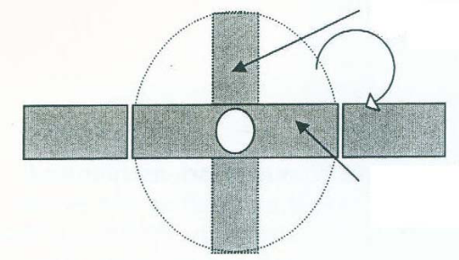
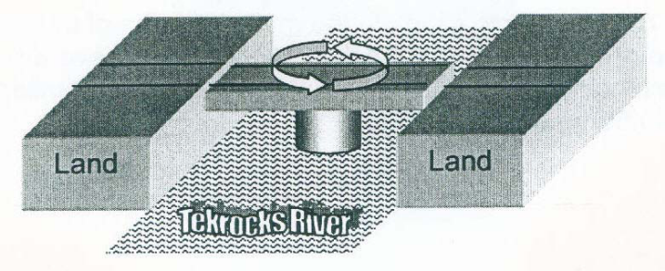
Duties:
Mechanical Engineer:
The bridge should be rotated by a motor. The rotational motion of this bridge should be slow and controlled. You must simulate the land on each side of the river that the bridge will connect. Leave a ½ in. gap between the bridge and land. Sketch your solution on the lab sheet in the mechanical engineering section, label all sensors and motors.
Electrical Engineer:
Your first mission will be to place two sensors on the bridge. One will be used to sense when the bridge is in the open position, and another will be used to sense when the bridge is in the closed position. Switches will be used to start the opening and closing process. Complete the wiring diagram on the lab sheet.
Computer Engineer:
You have the job of creating a program that will control this bridge. The bridge should start in the closed position (to allow the train to pass). When a button is pressed, the bridge should rotate until it reaches the open position. When the button is pressed a second time, the bridge should rotate back to the closed position. Your program should use the input from a potentiometer, to sense the location of the bridge. The bridge should not rotate more than 90 degrees in any direction. Open the PLTW Template and Save As Bridge to your directory. Complete each section:
- Heading
- Task Description
- Pseudocode
- Motor and Sensors Setup
- Program
Print and attach to the lab sheet. Show your completed Tekrocks Bridge to your instructor when you turn in your lab sheets.

Task #7 – Road Trip | 
Mission:
You and Alex have decided to drive to a movie. Before you can leave home, you need to prove to your parents that you really know how to drive a car. Your mission is to prove how responsible you are by simulating your trip to the movies using the VEX parts. Your car will need a motor, headlights and back-up lights.

Here is Your Itinerary:
- Turn the headlights on.
- Put the vehicle in reverse to back to the right out of the driveway for 2 seconds. Whenever your car is in reverse make sure your back-up lights are on.
- Stop the vehicle for at least 2 seconds before going forward and turn off the back-up lights.
- Put the vehicle in forward to drive down the road toward Alex’s house for 5 seconds.
- Upon arrival at Alex’s house, turn right onto the Broadway to park on the street. Turn the vehicle and headlights off.
- After 4 seconds, Alex gets in the car and it’s time to go.
- Turn the headlights on and put the vehicle in drive.
- Drive down the road until reaching the theater (a 3 second drive).
- Turn left into the theater and park the car by turning the vehicle and headlights off. Watch the world’s shortest movie. 5 seconds later, get back in the car.
- Turn the headlights on and put the vehicle in reverse to back to the right out of the parking spot (2 seconds). Don’t forget the back-up lights should come on whenever your car is in reverse.
- Stop the vehicle for 2 seconds before going forward. Turn off the back-up lights.
- Put the vehicle in drive and drive back to your house, Alex is spending the night. (a 4 second drive on Broadway, turn left, then a 5 second drive on Lake Rd.)
- Turn left into the driveway and shut off the vehicle and lights.
- You are home again.

Bonus:
Experiment with wait times to get your vehicle to return to within 10 in. of the same location it started from.
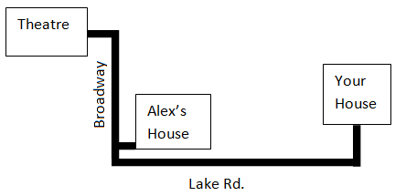
Duties:
Mechanical Engineer: Build a VEX model of a car with two motors, headlights and back up light(s). Sketch your solution on the lab sheet in the mechanical engineering section, label all sensors and motors.

Electrical Engineer: Wire the motors and lights to the microcontroller. Complete the wiring diagram on the lab sheet.

Computer Engineer: Write a program that will simulate your night out. Natural Language Functions will make your program efficient. Open the PLTW Template and Save As RoadTrip to your directory. Complete each section:
- Heading
- Task Description
- Pseudocode
- Motor and Sensors Setup
- Program
Print and attach to the lab sheet. Show your completed Road Trip to your instructor when you turn in your lab sheets.

Task #8 – Stay on Course | 
Mission: The US Army has been promoting the use of autonomous vehicles in the battlefield. In this challenge your team will design, build and program an autonomous vehicle that follows a ½ in black line so as to stay off the hostile battlefield. At a marked point on the course the vehicle must stop to drop off supplies, then continue back to base and stop.

Duties:
Mechanical Engineer: You must build an autonomous vehicle that follows a path to deliver supplies to troops and returns to base. Sketch your solution on the lab sheet in the mechanical engineering section, label all sensors and motors.

Electrical Engineer: You must work with the mechanical engineer and computer engineer to wire the motors and line tracker sensors. Complete the wiring diagram on the lab sheet.

Computer Engineer: Create a program that will drive an autonomous vehicle that senses a line, senses the drop off point, waits while the cargo is unloaded and then continues back to the base and stops. Open the PLTW Template and Save As StayOnCourse to your directory. Complete each section:
- Heading
- Task Description
- Pseudocode
- Motor and Sensors Setup
- Program
Print and attach to the lab sheet. Show your completed Stay On Course project to your instructor when you turn in your lab sheets.

Task #9 – Pick and Place | 
Mission:
You are a robotics engineering team at Got’em Little Manufacturing Company. At the end of the manufacturing process, the robot picks up the manufactured parts and places them in containers for shipping. Your job is to build and test the automated system. To begin the task, your team must decide how many and what type of sensors the robot will use.

Duties:
Mechanical Engineer: You must design a robot that when a pushbutton is pressed will pick up and place parts using the claw end effector. At one end of its travel, the arm will pick up a manufactured part. At the other end, it will drop the part into a bin, return to the starting point to pick up another part, and so on. Sketch your solution on the lab sheet in the mechanical engineering section, label all sensors and motors.

Electrical Engineer: You must work with the mechanical engineer and computer engineer to wire the appropriate motors and sensors to the microcontroller. Complete the wiring diagram on the lab sheet.

Computer Engineer: While the other engineers are busy working, you must write a program that will control the robot. Once the program has been started, the robot will move to the pick-up point. A sensor will signal the robot to stop and pick up the part using the claw. The robot will then move to the opposite end of its travel where it will drop the part in the bin. The robot will repeat this process every time a pushbutton switch is pressed. Open the PLTW Template and Save As PickPlace to your directory. Complete each section:
- Heading
- Task Description
- Pseudocode
- Motor and Sensors Setup
- Program
Print and attach to the lab sheet. Show your completed Pick and Place Robot to your instructor when you turn in your lab sheets.

Task #10 – Freight Elevator Challenge | 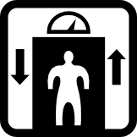

Mission:
You are an employee at a VEX factory. Your job requires you to deliver parts to various floors of the factory. Since a lifetime of climbing up and down stairs doesn’t sound attractive to you, you seek an alternative. Luckily, you have found a solution to this problem. Before a full-sized freight elevator can be built, a fully functioning scaled model must be built.
Bonus:
The elevator remains on the floor and waits for the next button is pressed instead of returning to the ground floor after each time it is called.

Duties:
Mechanical Engineer: The VEX factory has three floors, so the elevator must have three stops: ground level, floor one, and floor two. The scale model must meet the following requirements:

- The ground floor should be the base.
- The first floor must be approximately three inches above the base.
- The second floor must be approximately six inches above the base.
- The elevator floor must be large enough to fit three limit switches. Use the line tracker sensors to determine the location of the elevator.
Sketch your solution on the lab sheet in the mechanical engineering section, label all sensors and motors.

Electrical Engineer: While the mechanical engineer is busy building the elevator, you will design the wiring for this elevator. Each floor needs a sensor to detect the approaching elevator. The sensors should be installed so that when the elevator is level with the corresponding floor it stops. An additional sensor must be installed on the first floor for people to call the elevator, and three sensors in the elevator to move from floor to floor. You are responsible for connecting all wires. Complete the wiring diagram on the lab sheet.

Computer Engineer: While the mechanical and electrical engineers are busy working, create a program that will control the elevator. Be extremely cautious with your design; you don’t want to trap people in the elevator. The program must meet the following requirements.
- When a button is pressed the elevator should rise to that floor, wait for 2 seconds, and then return to the ground floor.
- Using input from installed sensors, you must program the elevator to stop at the selected floor.
- The elevator must be ready for use at all times, so your program must be repeatable.
Open the PLTW Template and Save As FreightElevator to your directory. Complete each section:
- Heading
- Task Description
- Pseudocode
- Motor and Sensors Setup
- Program
Print and attach to the lab sheet. Show your completed Freight Elevator project to your instructor when you turn in your lab sheets.

